DEPARTMENT OF
UNIVERSITY INSTITUTE OF COMPUTING
CHANDIGARH UNIVERSITY

Project: Sales Report Automation
Subject Name: Office Automation
Subject Code: 25CAP-104

Submitted to: Professor Anika Garg
Submitted by: Tatenda Chikopfa, Susan Masunga, Hlei Nai
Class/Section: 25BCA-2B
UID:25BCA10438 ,25BCA10360,25BCA10399

SALES REPORT AUTOMATION: REPORT
I. Aim
This report presents the design and implementation of a Sales Report Automation system aimed at improving the efficiency and accuracy of business reporting processes. Manual preparation of sales reports is time consuming and prone to human errors, which often affects the decision-making process. The automation of sales reports ensures that data is collected, processed, and presented in a timely and consistent manner. Using automation tools and programming technologies, this project simplifies the reporting workflow by generating sales summaries, charts, and insights automatically. The system enhances productivity, accuracy, and decision-making in organizations by providing real-time sales analytics.

1. Introduction
In modern business environments, data driven decision making has become an essential practice. Sales data, in particular, plays a critical role in determining a company’s performance, market position, and profitability. Traditionally, generating sales reports involves manual data collection, aggregation, and formatting, which can lead to inconsistencies and inefficiencies. The Sales Report Automation project addresses these challenges by developing an automated system that generates accurate and timely sales reports with minimal human intervention.
The automation process involves integrating data from multiple sources, performing data processing, and producing well-structured reports in various formats. This approach allows organizations to focus more on analysis and strategy rather than administrative tasks.

2. Objectives
The main objectives of the Sales Report Automation project are as follows:
- To automate the process of generating sales reports from raw data sources.
- To reduce human error and ensure consistency in data presentation.
- To enhance the speed and efficiency of report preparation.
- To provide real time insights into sales performance through visual dashboards.
- To improve managerial decision-making through reliable, automated data reporting.

3. Literature Review
Sales automation has been widely recognized as a means to improve business intelligence and efficiency. According to Singh and Gupta (2021), automated reporting systems reduce time consumption and enhance decision quality by eliminating repetitive manual tasks. Similarly, a study by Li and Zhao (2020) highlighted that automation in business reporting improves accuracy and data visibility, enabling managers to respond quickly to market changes.
The integration of data analytics tools such as Power BI and Tableau has further transformed how organizations visualize sales data (Kumar, 2022). These tools, combined with programming languages like Python, allow for advanced data manipulation and presentation in automated workflows.

4. System Design and Methodology
The system design for the Sales Report Automation project follows a structured approach:
The Automated Process
Data Collection → Data Processing → Report Generation → Distribution
4.1 Data Collection
The system retrieves data from multiple sources such as point-of-sale systems, e-commerce platforms, and databases. The data is imported automatically through APIs or scheduled scripts.
4.2 Data Cleaning and Processing
Collected data often contains duplicates or inconsistencies. Data cleaning ensures that only valid, relevant, and accurate data is used for report generation. Python’s Pandas library or SQL queries can be employed for data manipulation.
4.3 Report Generation
The processed data is automatically compiled into comprehensive reports. These reports include total sales, top-performing products, revenue growth trends, and regional sales performance. Reports can be exported as Excel sheets, PDFs, or dynamic dashboards.
4.4 Report Distribution
Once generated, the reports are automatically sent to relevant departments or stakeholders through email or cloud-based dashboards.

5. Technologies Used
- Programming Language: python
- Database Management: MySQL / Google Sheets
- Automation Tools: Power Automate / Cron Jobs
- Data Analysis and Visualization: Power BI / Tableau
- Libraries and Frameworks: Pandas, Matplotlib, Seaborn
- File Formats: PDF, Excel, CSV

9.Implementation Roadmap
Phase 1: Assessment (Week 1-2)
· Identify key reports for automation
· Map current data sources and flows
· Set success metrics and KPIs

Phase 2: Tool Selection (Week 3-4)
· Evaluate automation platforms
· Choose visualization tools
· Plan integration approach

Phase 3: Development (Week 5-8)
· Build data pipelines
· Create report templates
· Develop dashboards
· Test automation workflows

Phase 4: Deployment (Week 9-10)
· Train team members
· Go-live with pilot reports
· Gather feedback and refine

Phase 5: Optimization (Week 11-12)
· Scale to additional reports
· Enhance features
· Continuous improvement

10. Results and Discussion
The implementation of the Sales Report Automation system demonstrated significant improvements in time efficiency and data reliability. Reports that previously took hours to compile manually were generated within minutes. Additionally, the automated system eliminated errors caused by manual data entry and formatting. The resulting reports were consistent, visually informative, and readily available for managerial use.
The system’s scalability also allows integration with larger databases and business applications. By automating repetitive reporting tasks, employees can dedicate more time to analytical and strategic decision-making activities.

11. Benefits
- Accuracy: Minimizes human error in calculations and formatting.
- Efficiency: Saves time by automating report generation.
- Real-time Insights: Provides up to date sales data for immediate decision making.
- Cost Reduction: Decreases administrative costs associated with manual reporting.
- Consistency: Ensures uniformity across all generated reports.
- Employee Satisfaction: Eliminates repetitive work
- Competitive Advantage: Faster response to market changes
- Scalability: Handles business growth effortlessly
12. Challenges
During implementation, several challenges were identified:
- Integrating data from multiple platforms with different formats.
- Ensuring data security and privacy.
- Managing large datasets efficiently.
- Training users to interpret and utilize automated reports effectively.

13. Conclusion
The Sales Report Automation project represents a significant advancement in business process automation. By reducing manual intervention and enhancing the accuracy and timeliness of sales data reporting, the system enables organizations to make informed decisions faster. It also lays the foundation for incorporating advanced analytics, predictive modelling, and AI driven insights in future upgrades.

14. Future Work
To further enhance the system, future work could focus on:
- Integrating predictive analytics for sales forecasting.
- Adding AI based anomaly detection for identifying unusual sales patterns.
- Enhancing mobile accessibility through responsive dashboards.
- Expanding integration capabilities with more data sources and ERP systems.

References
- Kumar, S. (2022). Data Visualization and Automation in Business Intelligence. Journal of Information Systems, 18(3), 45–59.
- Li, J., & Zhao, Y. (2020). Improving Decision-Making through Automated Business Reporting. International Journal of Management Information, 15(2), 102–118.
- Singh, R., & Gupta, P. (2021). Automation in Sales Analytics and Its Impact on Business Performance. International Journal of Computer Science and Applications, 12(4), 67–75.

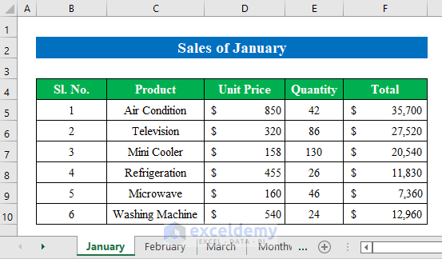

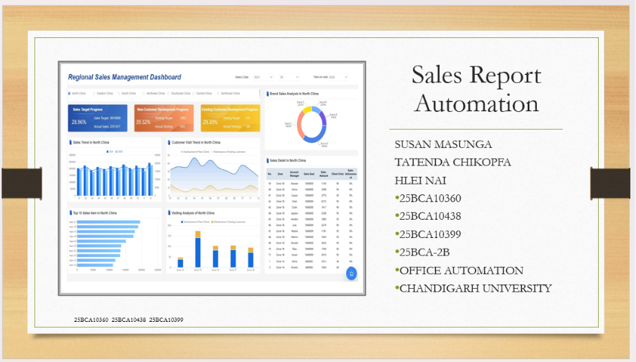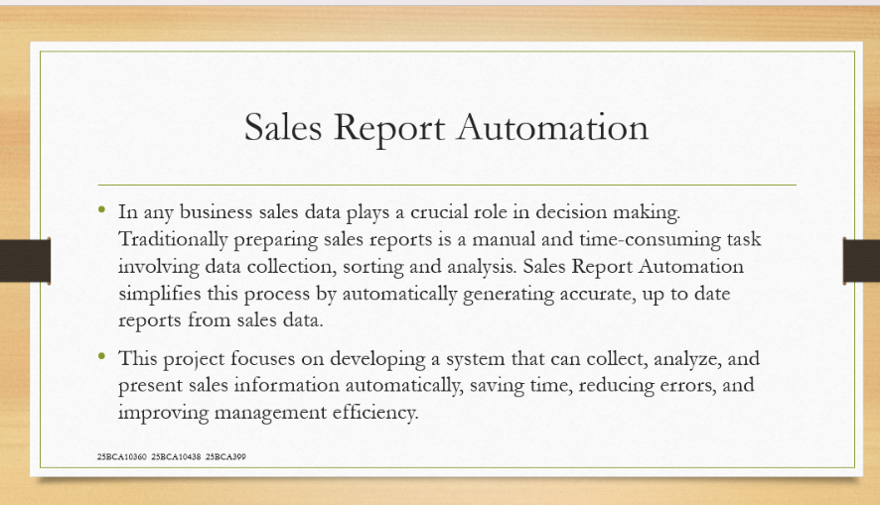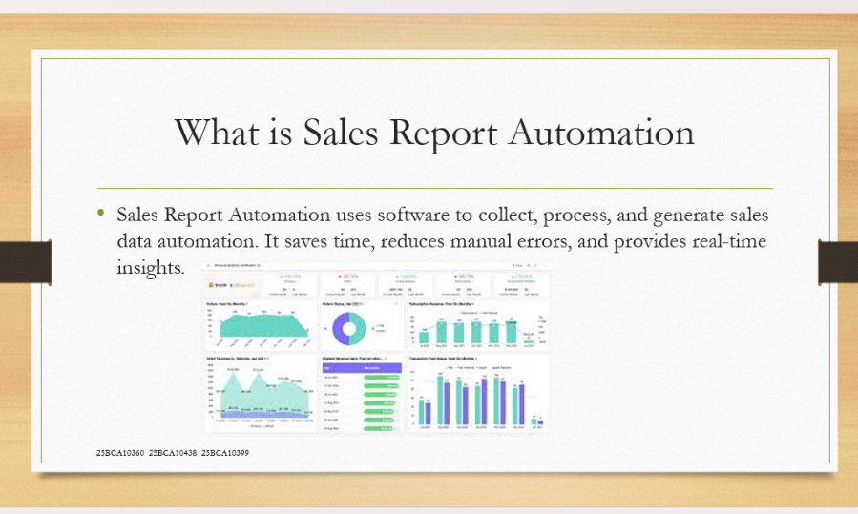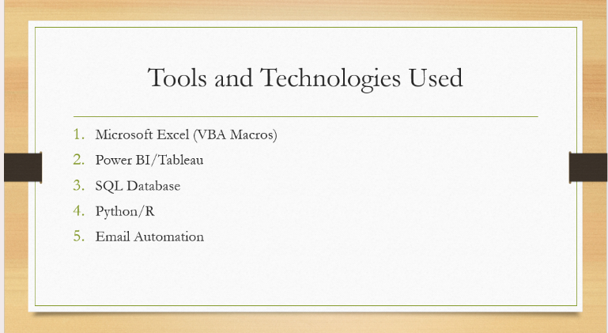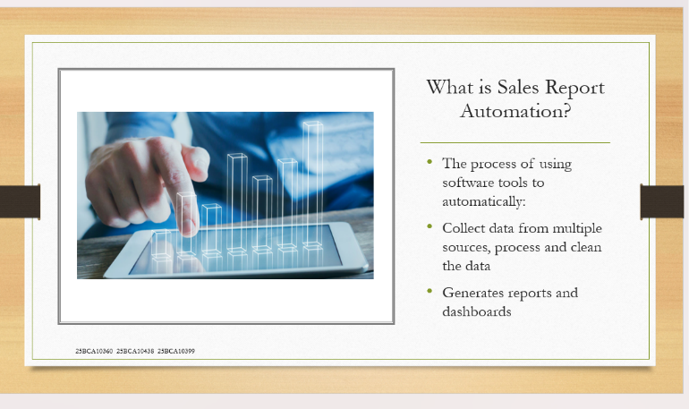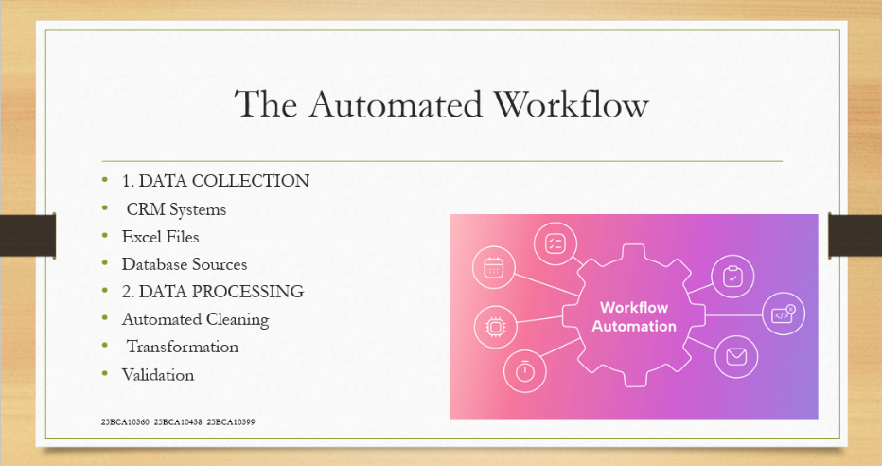
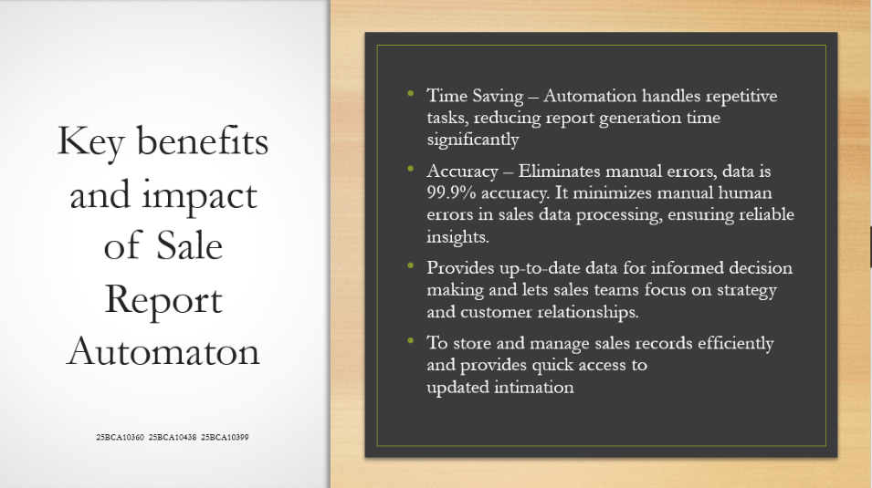
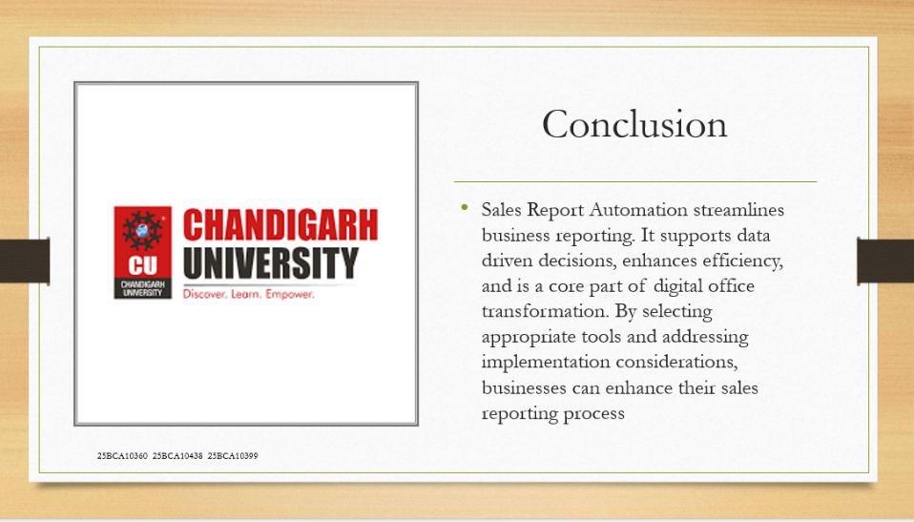
SALES REPORT AUTOMATION: CASE STUDY
In today’s competitive business environment, timely and accurate sales reporting is essential for informed decision making. Traditional manual reporting methods are time-consuming, error prone, and often delay critical insights. This case study explores how automating the sales reporting process using modern business analytics tools can improve efficiency, data accuracy, and strategic decision making within an organization.

Case Study: Implementation of Sales Report Automation in XYZ Retail Pvt. Ltd.
Company Background
XYZ Retail Pvt. Ltd. is a mid-sized retail chain based in India, operating 30 outlets across northern states. The company sells consumer electronics and household products and employs over 200 sales representatives.
Before automation, the organization managed its sales reporting manually using Excel sheets submitted by each store daily.
Challenges Before Automation
1. Time Consuming Reporting Process:
Each branch submitted daily sales data manually to the head office. Compiling and verifying these reports took 3 to 4 hours daily.
2. Data Inconsistency and Errors:
Manual entry often caused discrepancies between store level data and head office summaries.
3. Delayed Decision Making:
Reports were reviewed weekly, resulting in delayed insights and missed opportunities to improve sales strategies.
4. Lack of Real Time Data:
Management had no live access to sales trends or performance dashboards.

Proposed Solution: Sales Report Automation System
To address these challenges, XYZ Retail implemented an Automated Sales Reporting System built using Excel Macros, SQL Database, and Power BI.
The system was designed to:
- Automatically collect sales data from each store’s POS system.
- Process and clean the data using Python scripts.
- Generate daily and monthly sales summaries automatically.
- Update a real-time dashboard accessible to managers via Power BI.
- Email formatted sales reports to management at the end of each day.
- Reduces manual errors and reporting delays.
- Provides management with clear and interactive visual dashboards

Implementation Process
1. Data Collection: Gather data from existing sales databases and spreadsheets.
2. Data Integration:
Each store’s POS data was linked to a central SQL database through secure APIs.
3. Automation Scripts:
Python scripts automated data extraction, cleaning, and report generation.
4. Visualization:
Power BI dashboards were created to show real-time performance metrics like daily sales, top performing products, and revenue targets.
5. Email Automation:
VBA macros triggered automatic email delivery of reports every evening.
6. Training & Rollout:
Staff were trained on system usage, troubleshooting, and report interpretation.
Results After Automation
Metric Before Automation After Automation Improvement
Metric | Before Automation | After Automation
Daily Reporting Time | 3 hours 10 minutes | 85% faster
Reporting Accuracy | 80% 99.5%reported weekly day | Automated  +6days saved
Report Delivery | Delayed | Real Time Immediate response
Decision Making | Delayed | Real time Immediate response
Employee Productivity | Moderate | High, more time for sales activities

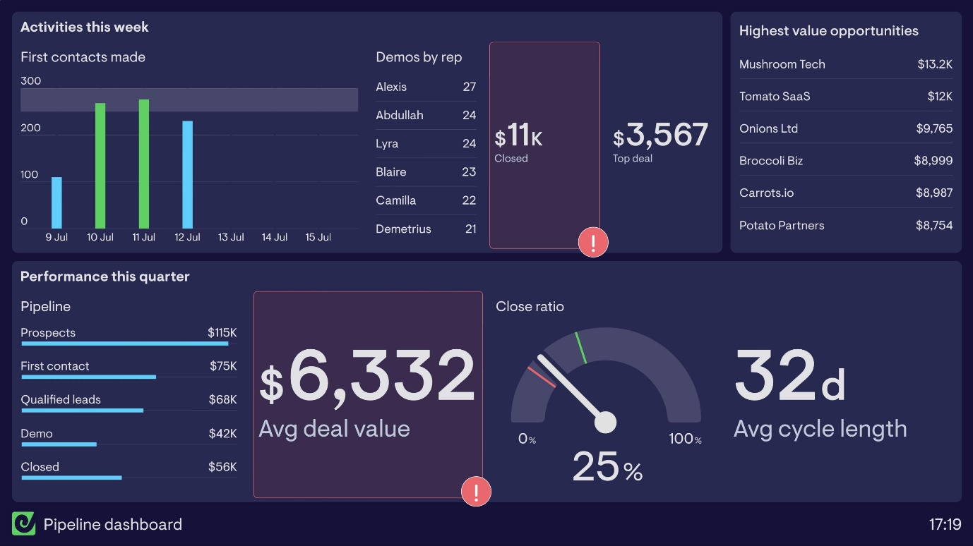
Impact and Benefits
After implementing the Sales Report Automation system, the organization observed:
- 40% reduction in reporting time.
- Improved accuracy of data with fewer manual entries.
- Enhanced decision making due to real time visual dashboards.
- Better collaboration between sales and management teams.
- Predictive forecasting helped plan sales strategies proactively.
Efficiency Boost: Managers could now focus on sales strategy instead of report compilation.
Data Transparency: Real time dashboards ensured everyone had access to the same accurate data.
Cost Reduction: Reduced need for manual data-entry staff and paper-based reports.
Improved Forecasting: Historical trends could be analysed instantly, improving demand forecasting.

Limitations and Future Improvements
Initial Setup Cost: Required investment in automation tools and staff training.
Technical Maintenance: Occasional system updates and script debugging needed.
Future Enhancements:
Integration with AI to predict sales trends.
Mobile dashboard for on-the-go access.

Conclusion
The automation of sales reporting at XYZ Retail Pvt. Ltd. transformed the company’s operational efficiency. The system drastically reduced report generation time, enhanced accuracy, and provided real-time business insights.
This case demonstrates how Sales Report Automation is a key driver in achieving digital office transformation, aligning with modern office automation principles
The Sales Report Automation system transformed the way sales data was collected, processed, and analysed. By replacing manual tasks with automated workflows and visual dashboards, the organization achieved greater efficiency, accuracy, and strategic control. Such automation can be scaled and customized for any industry, making it a powerful solution for modern data-driven enterprises.
References
- Microsoft Power BI Documentation (2Power)
- Tableau Business Intelligence Guide
- Data-Driven Decision Making in Sales Management" – Journal of Business Analytics, 2023

